**Gregory, Augusta (1852-1932)**

Born Isabella Augusta Persse in County Galway, Ireland in 1852, Lady Augusta Gregory was a playwright, folklore collector, essayist, and co-founder of the Abbey Theatre. Following the death of husband Sir William Gregory of Coole Park in 1892, she became a leading member of the Irish Revival, working to establish Irish culture as an alternative to colonial culture and rule. To this end, she published several collections of Irish folklore and established a branch of the Gaelic League at her home at Coole in the west of Ireland. Her most significant contribution to Irish cultural life was through her collaboration with W. B. Yeats, with whom she and Edward Martyn established the Irish Literary Theatre in 1899. Gregory also co-wrote *Kathleen ni Houlihan* (1902) with Yeats, and the two launched the Abbey Theatre in Dublin in 1904, together with J. M. Synge. Gregory wrote plays for the Abbey stage and piloted its development as one of the nation’s most important institutions, overseeing productions of key works by Synge, George Bernard Shaw, and Sean O’Casey.

Gregory’s concern with cultural heritage informed all her work, from the folklore collections *Cuchulainn of Murtheimne* (1902) and *Gods and Fighting Men* (1904) to her plays, including *The Rising of the Moon* (1907), *Spreading the News* (1905), *The Gaol Gate* (1906), *Dervorgilla* (1907). Her version of the Diarmaid and Grania saga, *Grania* (pub. 1910), was not performed in her lifetime and is her most overtly feminist work, emphasising the role that Grania plays in determining her own fate and in choosing an independent and sexually rewarding life over a passive role as consort. Gregory’s best-known play, *Kathleen ni Houlihan*, depicts an Irish family on the day of their son’s marriage. During the course of the day, an old woman who has been dispossessed of her ‘four green fields’ calls at the house and diverts the son so that he pledges to fight to regain her land. The nationalist implications of the play are clear and were underscored in the first production by the casting of nationalist leader Maud Gonne in the title role.

Gregory was also an important non-fiction writer, including her history of the founding the Abbey, *Our Irish Theatre* (1913), her journalism for *The Nation*, cataloguing atrocities during the War of Independence (1920-21), and her autobiography *Seventy Years* (pub. 1974). She died at Coole in 1932.

**List of Works**

Gregory, Augusta. (1970) *The Collected Plays*, 4 vols., ed. Ann Saddlemyer, Gerrards Cross: Colin Smythe.

----- (1995) *Selected Writings*, ed. Lucy McDiarmaid and Maureen Waters, London: Penguin.

----- (1976) *Seventy Years: Being the Autobiography of Lady Gregory*, ed. Colin Smythe, New York: Macmillan.

**References and Further Readings**

Fogarty, Anne. (ed.) (2004) *Lady Gregory Special Issue, Irish University Review*, 34 (1) (Spring/Summer).

Hill, Judith. (2011) *Lady Gregory: An Irish Life*, Cork: Collins.

Kohlfeldt, Mary Lou. (1985) *Lady Gregory: The Woman Behind the Irish Literary Renaissance*, London: Deutsch.

Leeney, Cathy. (2010) *Irish Women Playwrights 1900-1939*, New York: Peter Lang.

McDiarmaid, Lucy, and Maureen Waters. (1995) Introduction, *Lady Gregory: Selected Writings*, London: Penguin.

**Emilie Pine, University College Dublin**

**Recommended Illustrations**

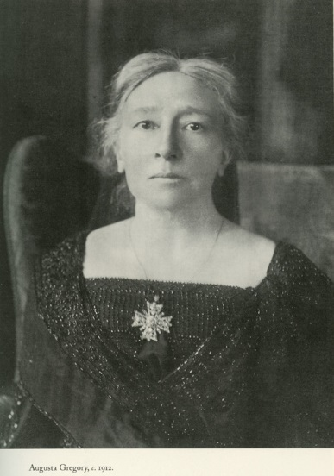

**Lady Augusta Gregory**

[Available at: <http://www.lissadellhouse.com/wbyeats.html>]

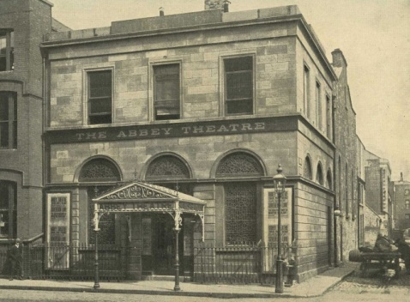

**The Abbey Theatre**

[Available at: <http://www.abbeytheatre.ie/behind_the_scenes/article/history> ]

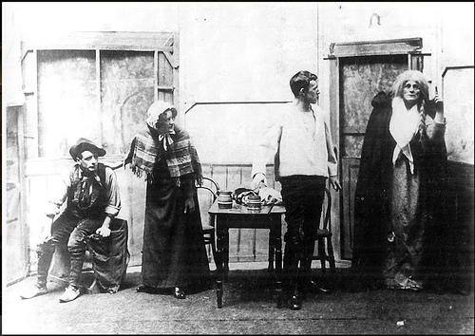

**Maud Gonne (right) in *Cathleen ni Houlihan*, staged at St. Teresa's Hall by W. G. Fay's Irish National Dramatic Company in 1902.**

[Available at: <http://www.nlu3a.org.uk/yeats-14th-february/> ]